Mendeley uDÿldx.h Download lsÍu

01. www.Mendeley.com fjí wvúhg msúfikak

02. Tnf.a mß.Klhg wod< operating system tlg kshñ; Mendeley version tl download lrkak. Wod(-Tnf.a mß.Klfhys operating system tl Windows kï Download Mendeley Desktop for Windows Clik lrkak
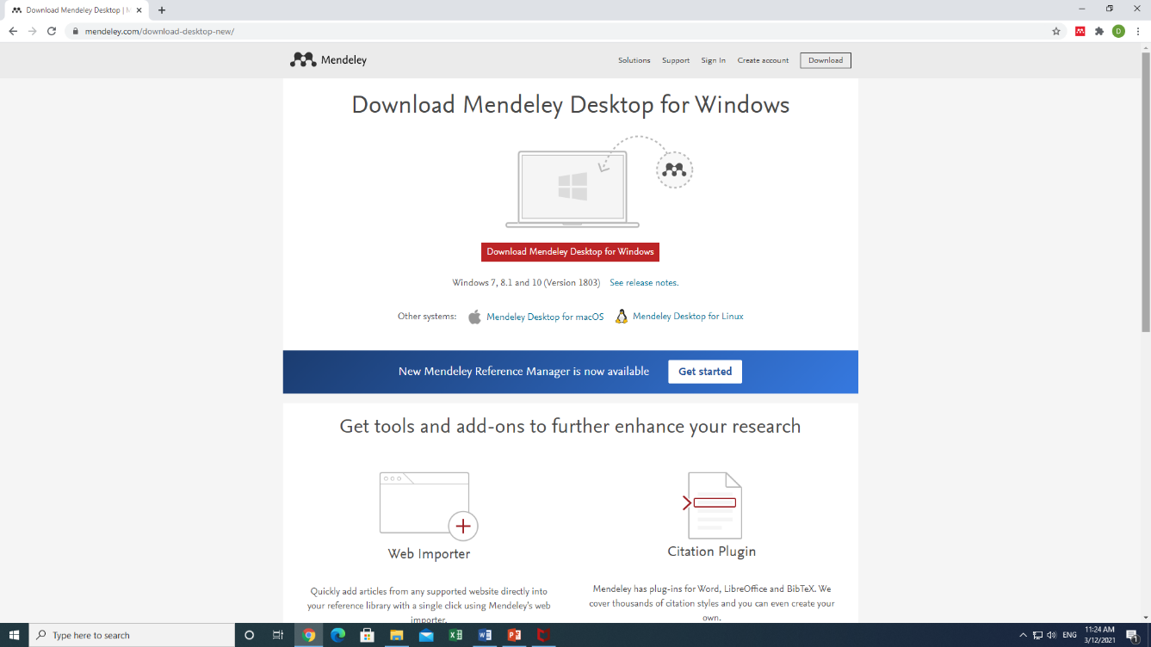

03. Mendeley Desktop for Windows file tl save lrkak

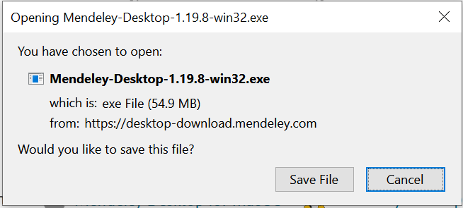

04. Click on Next
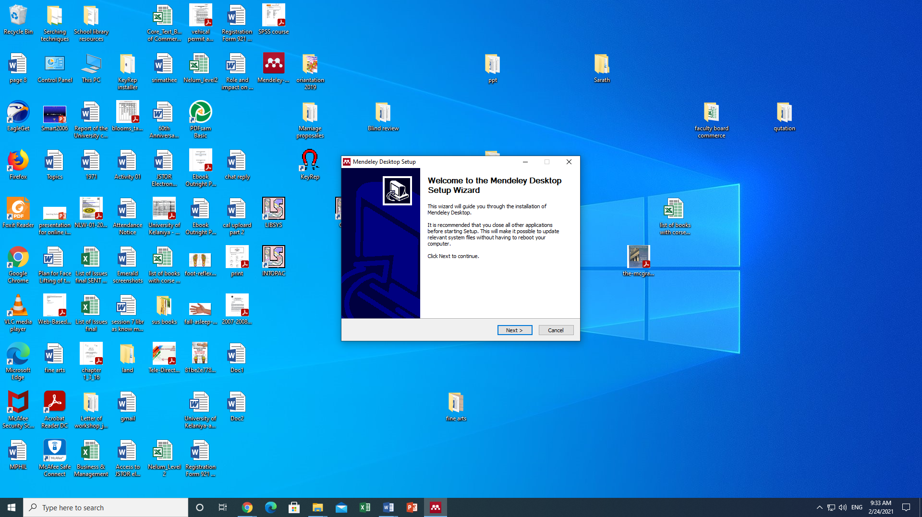

05. I agree click lrkak

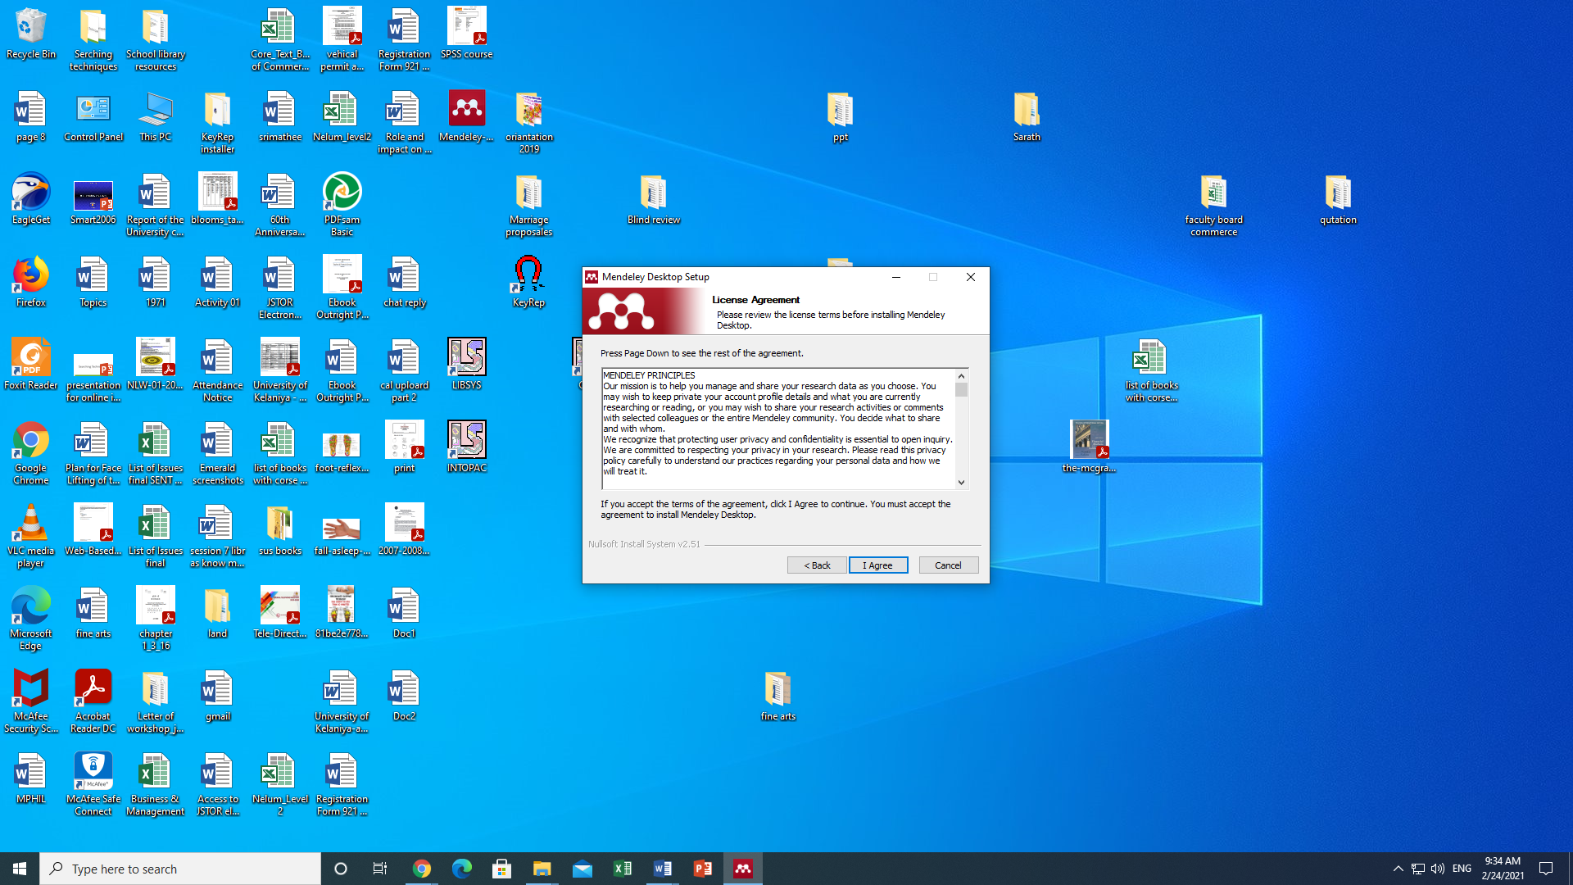

06. Medeley for desktop uDÿldx.h Tnf.a mß.Klhg save lsÍug wod< ia:dkh f;darkak
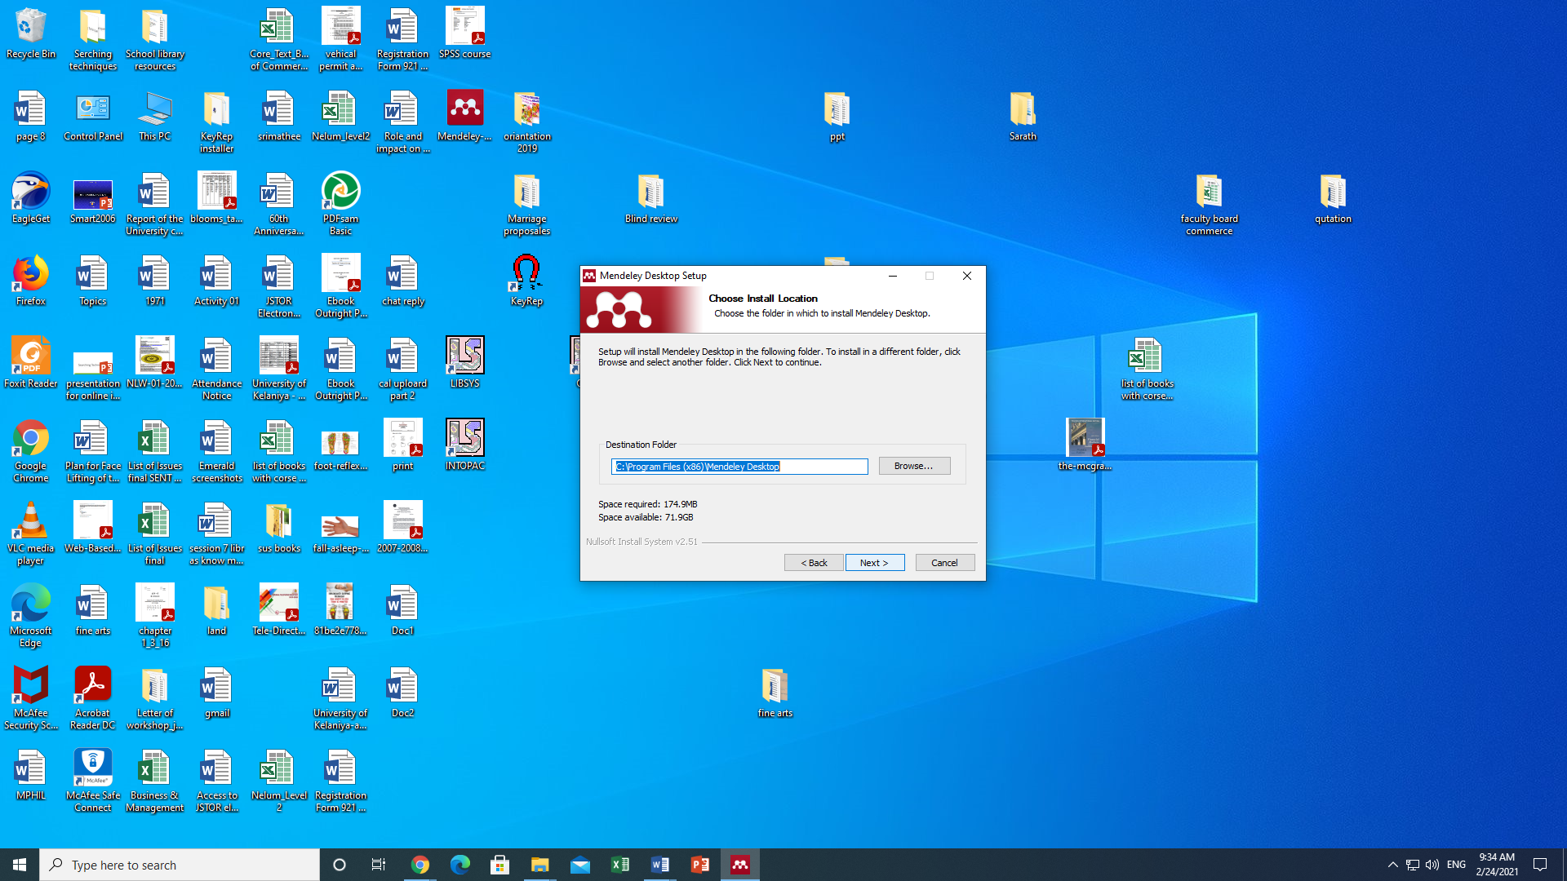
07. Install click lrkak
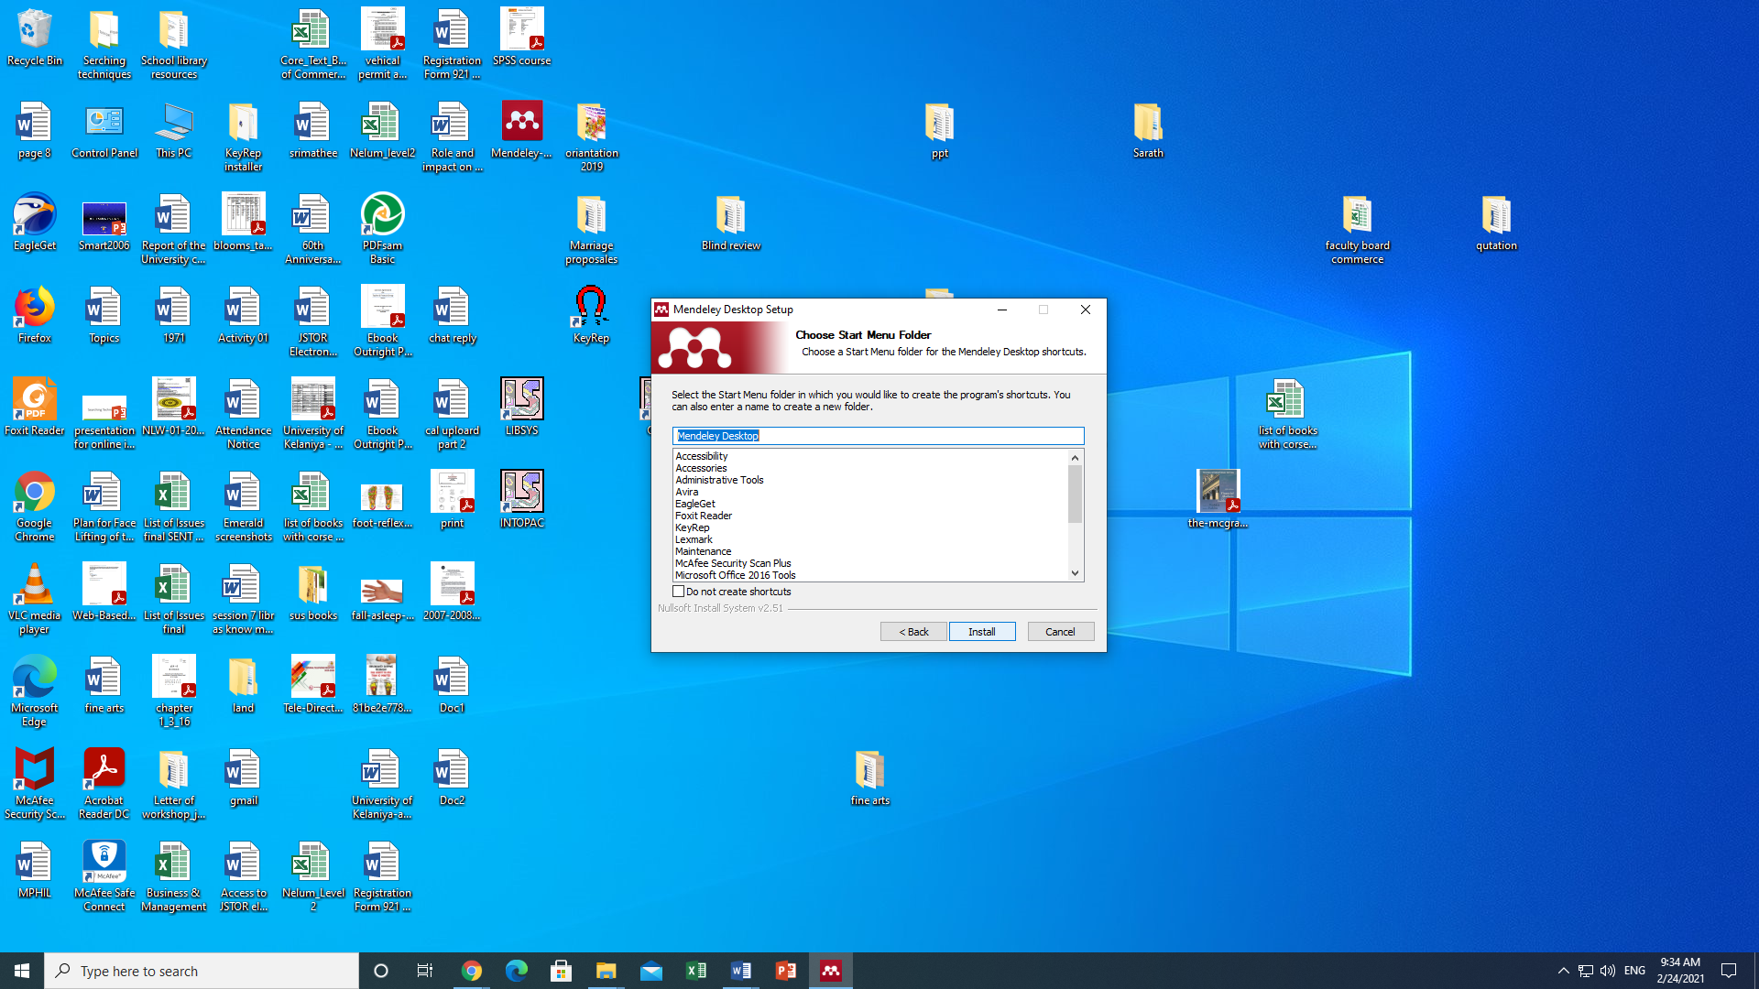

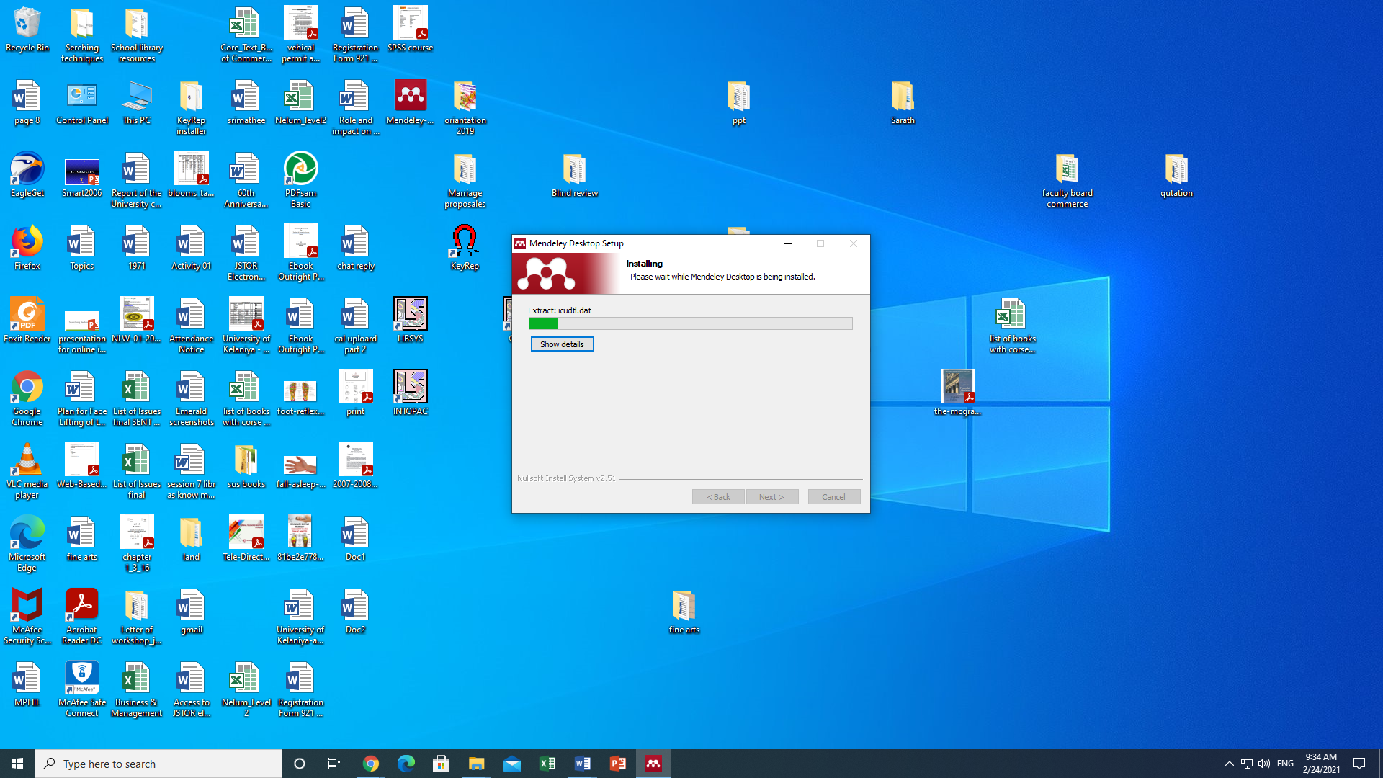

08. Mendeley uDÿldx.h install lsÍu wjika lsßu i|yd finish click lrkak

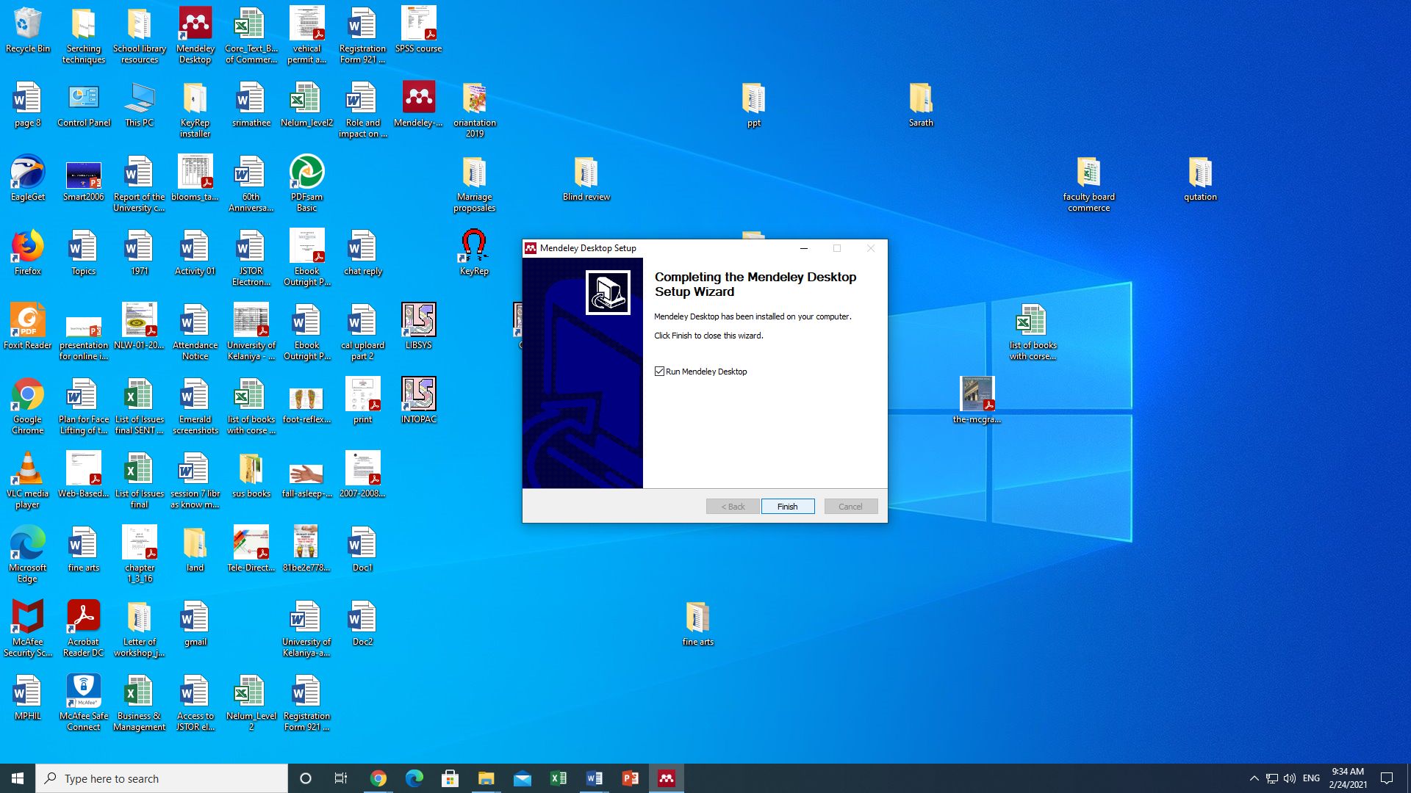

09. Mendeley uDÿldx.h Ndú; lsÍu i|yd Mendeley for Desktop whslkh click lrkak

