Mendeley uDÿldx.h Ndú; lsÍu i|yd Web Importer Install lsÍu

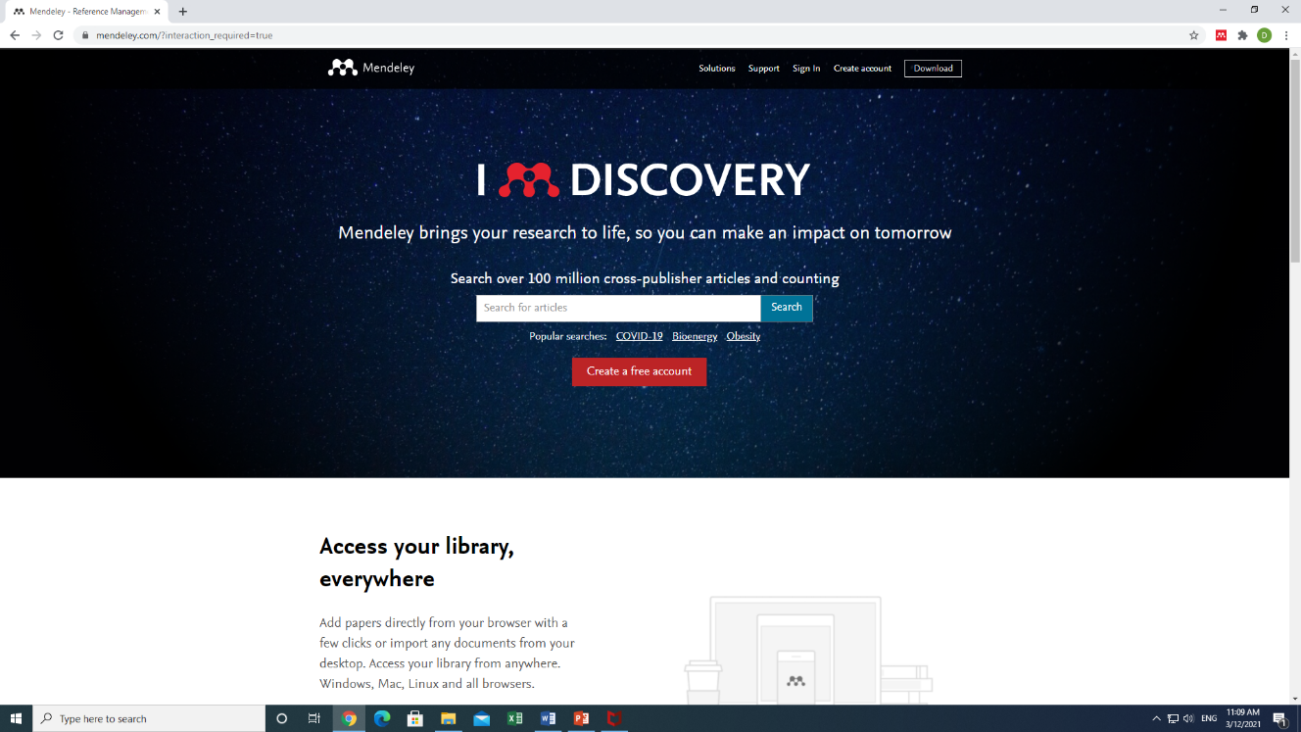
01. www.Mendeley.com fjí wvúhg msúfikak

02. Web Importer hgf;a we;s " Find Out more" click lrkak

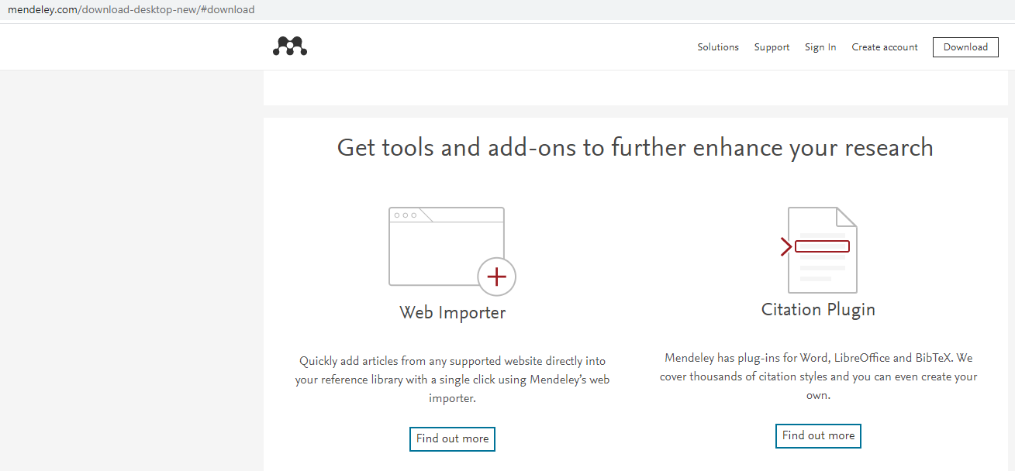
03. Get Web Importer for Chrome hkak click lrkak

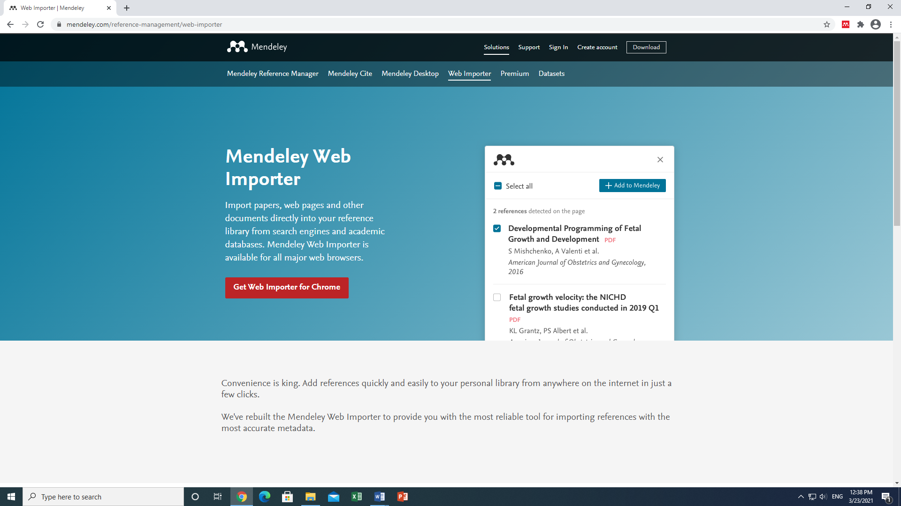

04. Add to Chrome hkak click lrkak
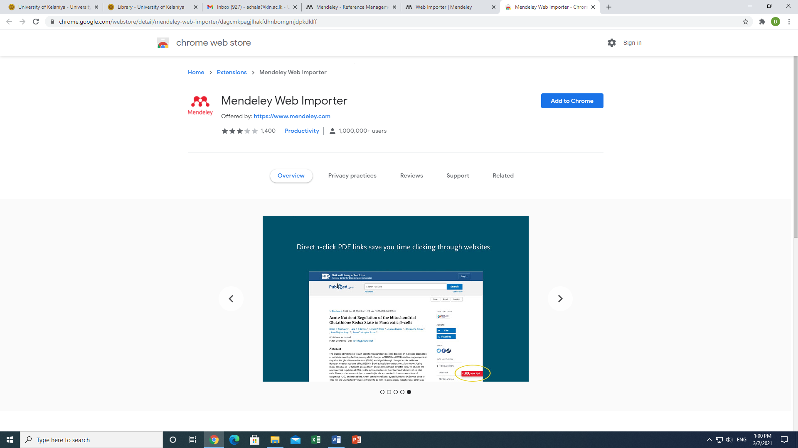

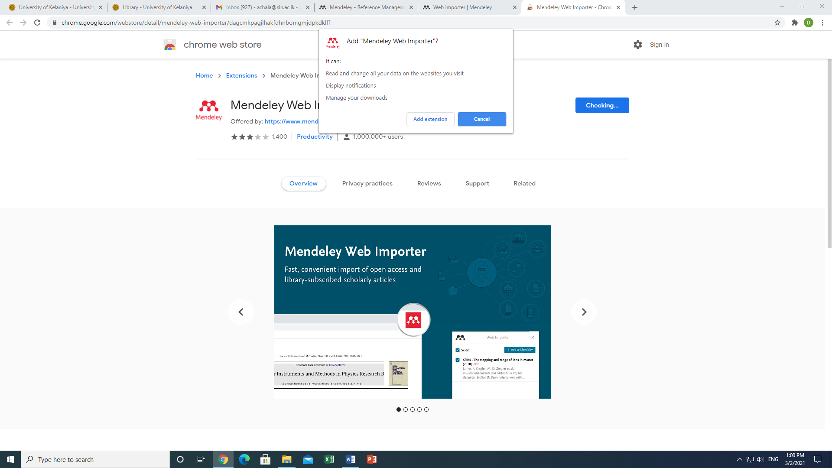

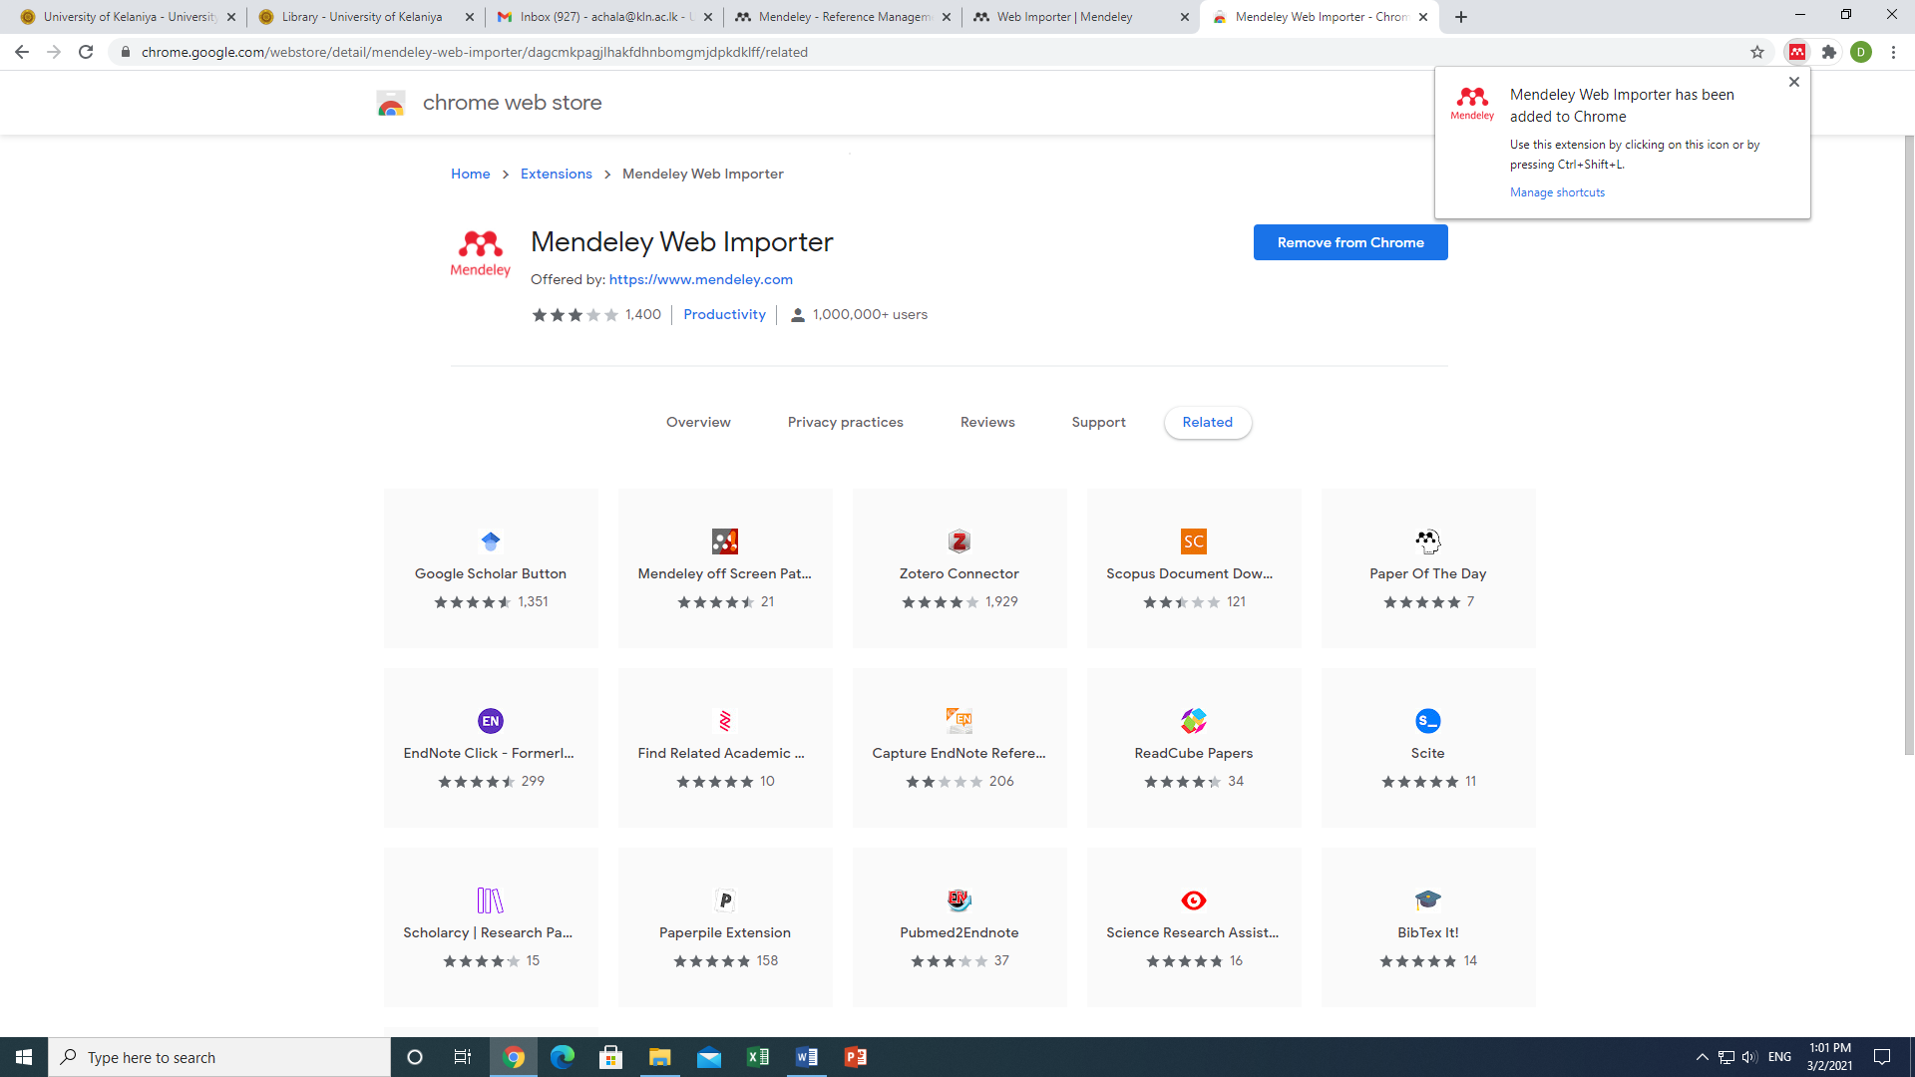

Tn ksjerÈ wdldrhg Mendeley Web Importer download lr we;akï Tnf.a Google Chrome fjí browser ;=, Tng Mendeley whslkh oel .; yelsh.

