Mendeley uDÿldx.h Ndú; lsÍu i|yd Word Pluging Install lsÍu

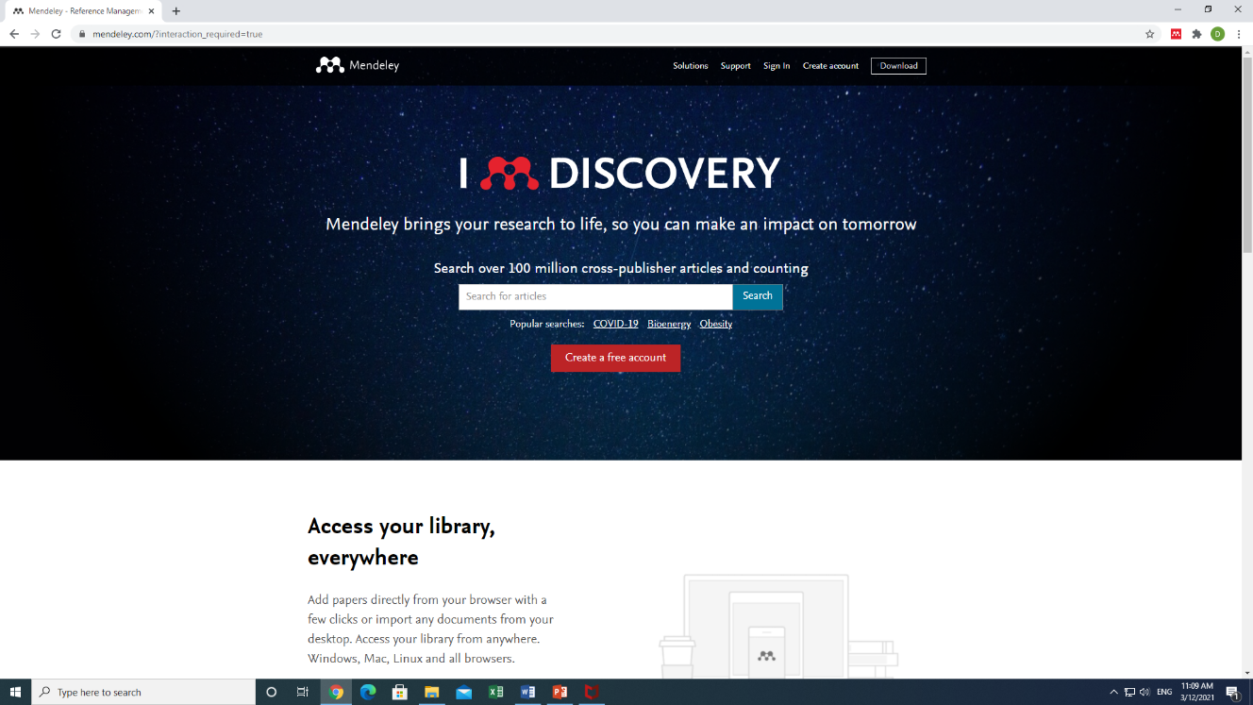
01. www.Mendeley.com fjí wvúhg msúfikak

02. Citation Pluging hgf;a we;s " Find Out more" click lrkak
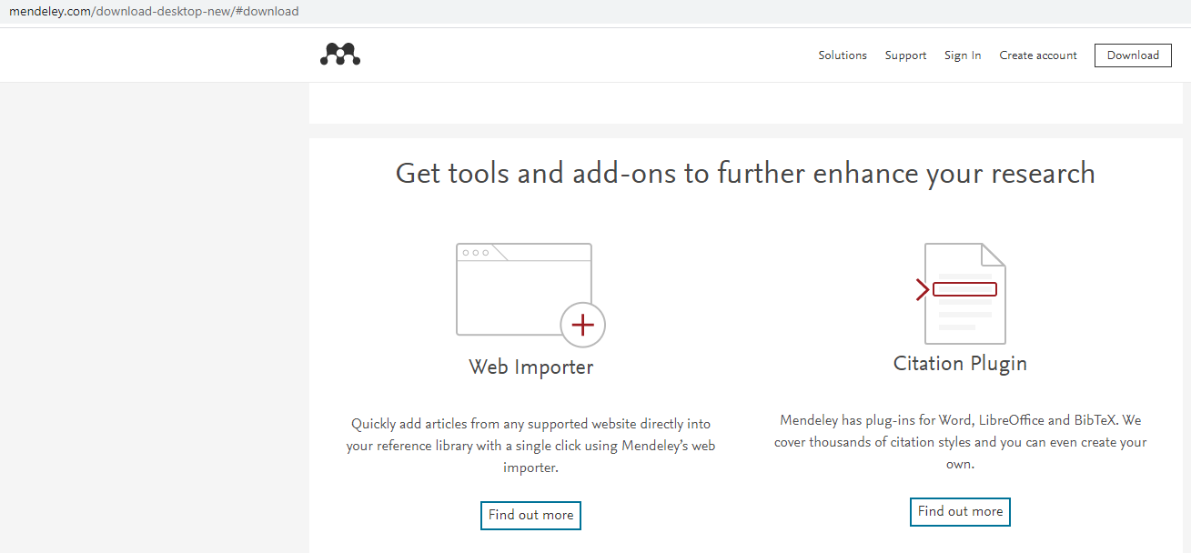
Mendeley word plugin Installation- Ms. Office 2016 isg by<g
03. Get Mendeley Cite hkak click lrkak
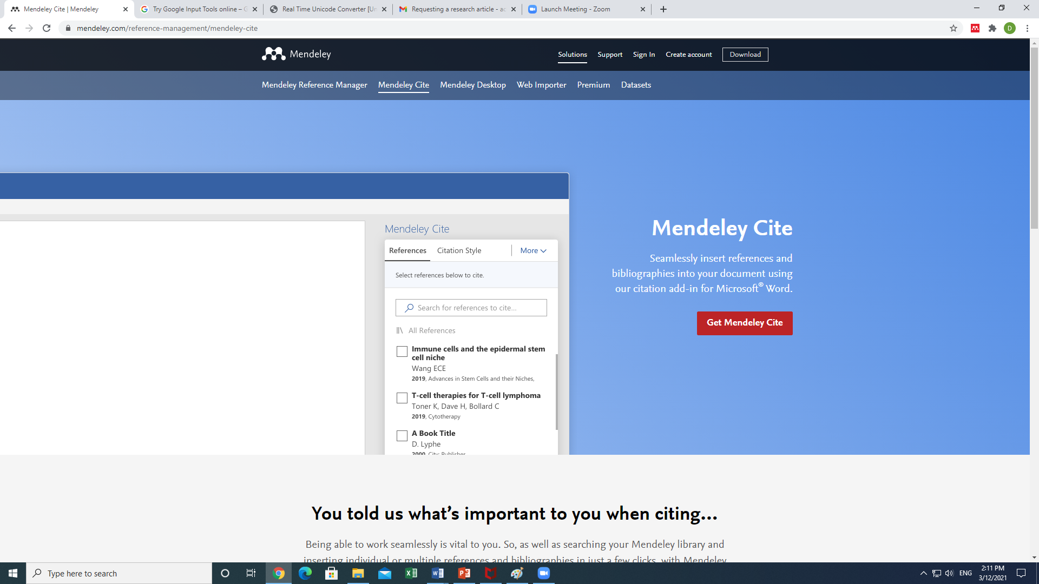

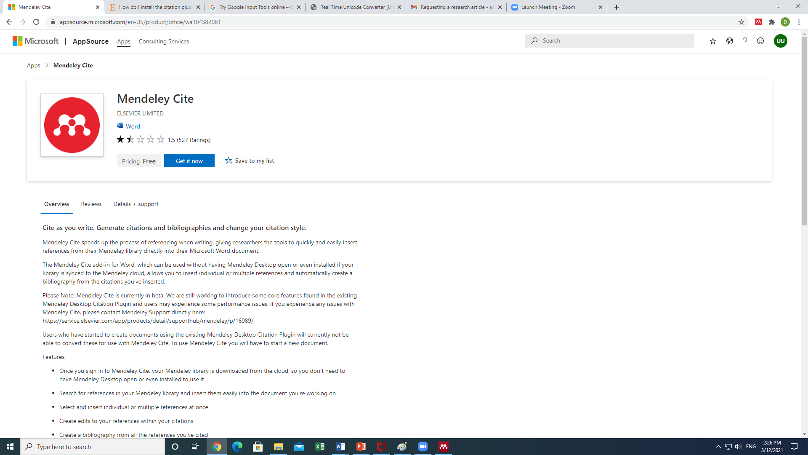
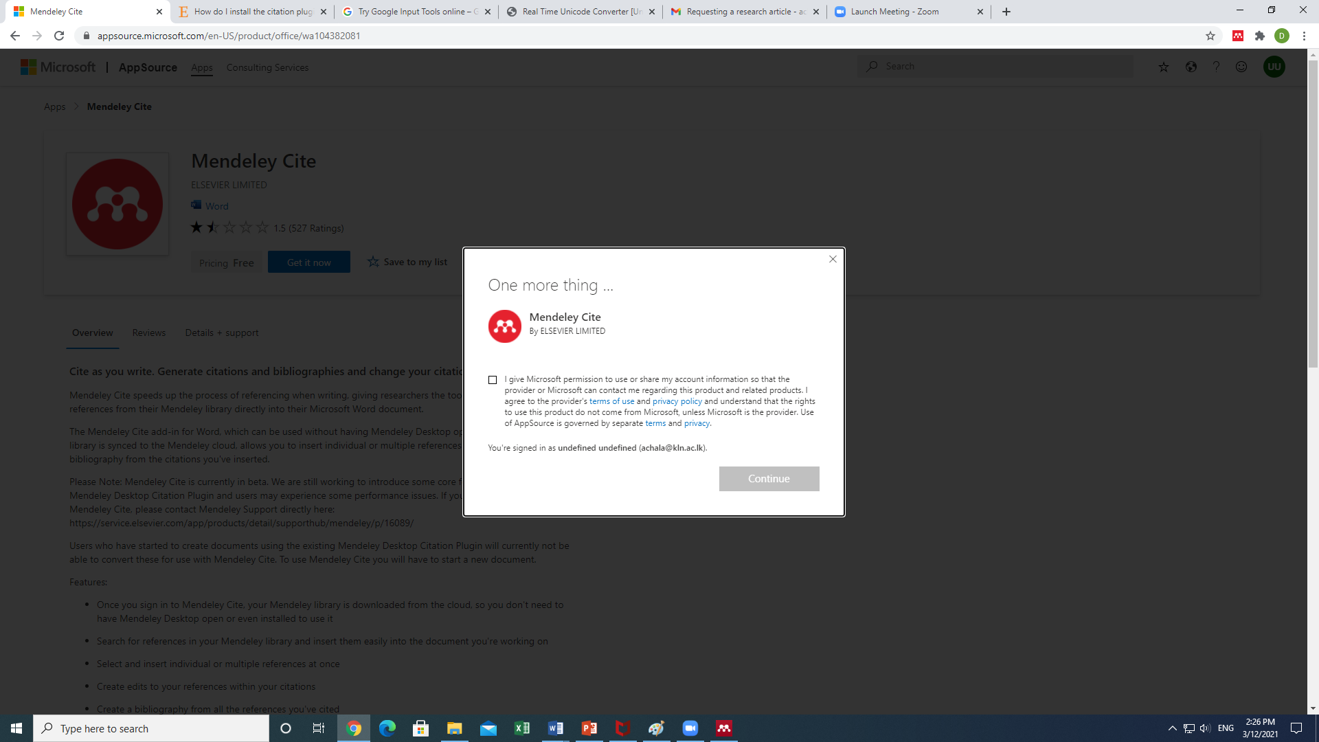

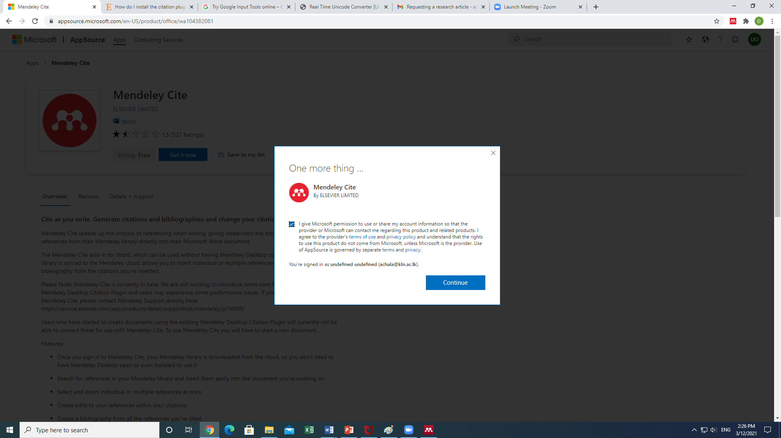
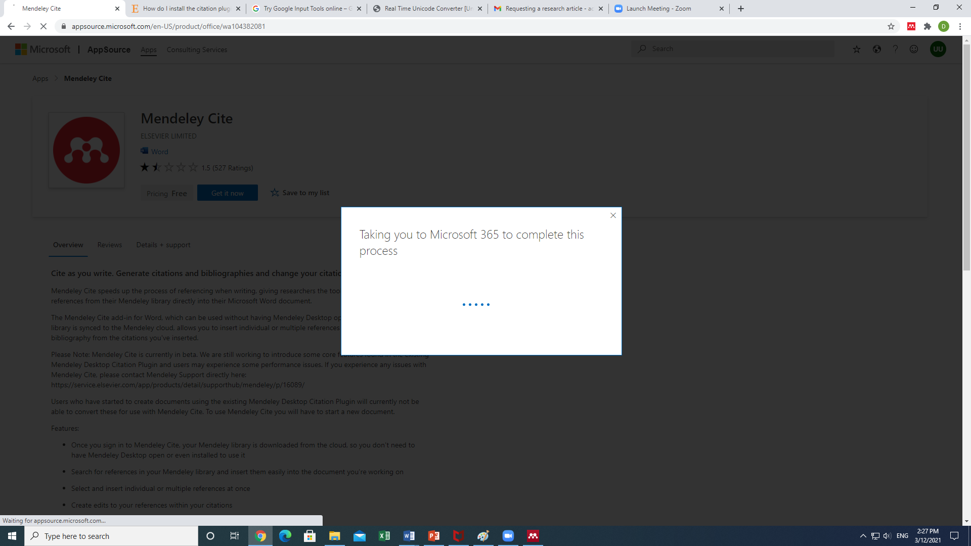

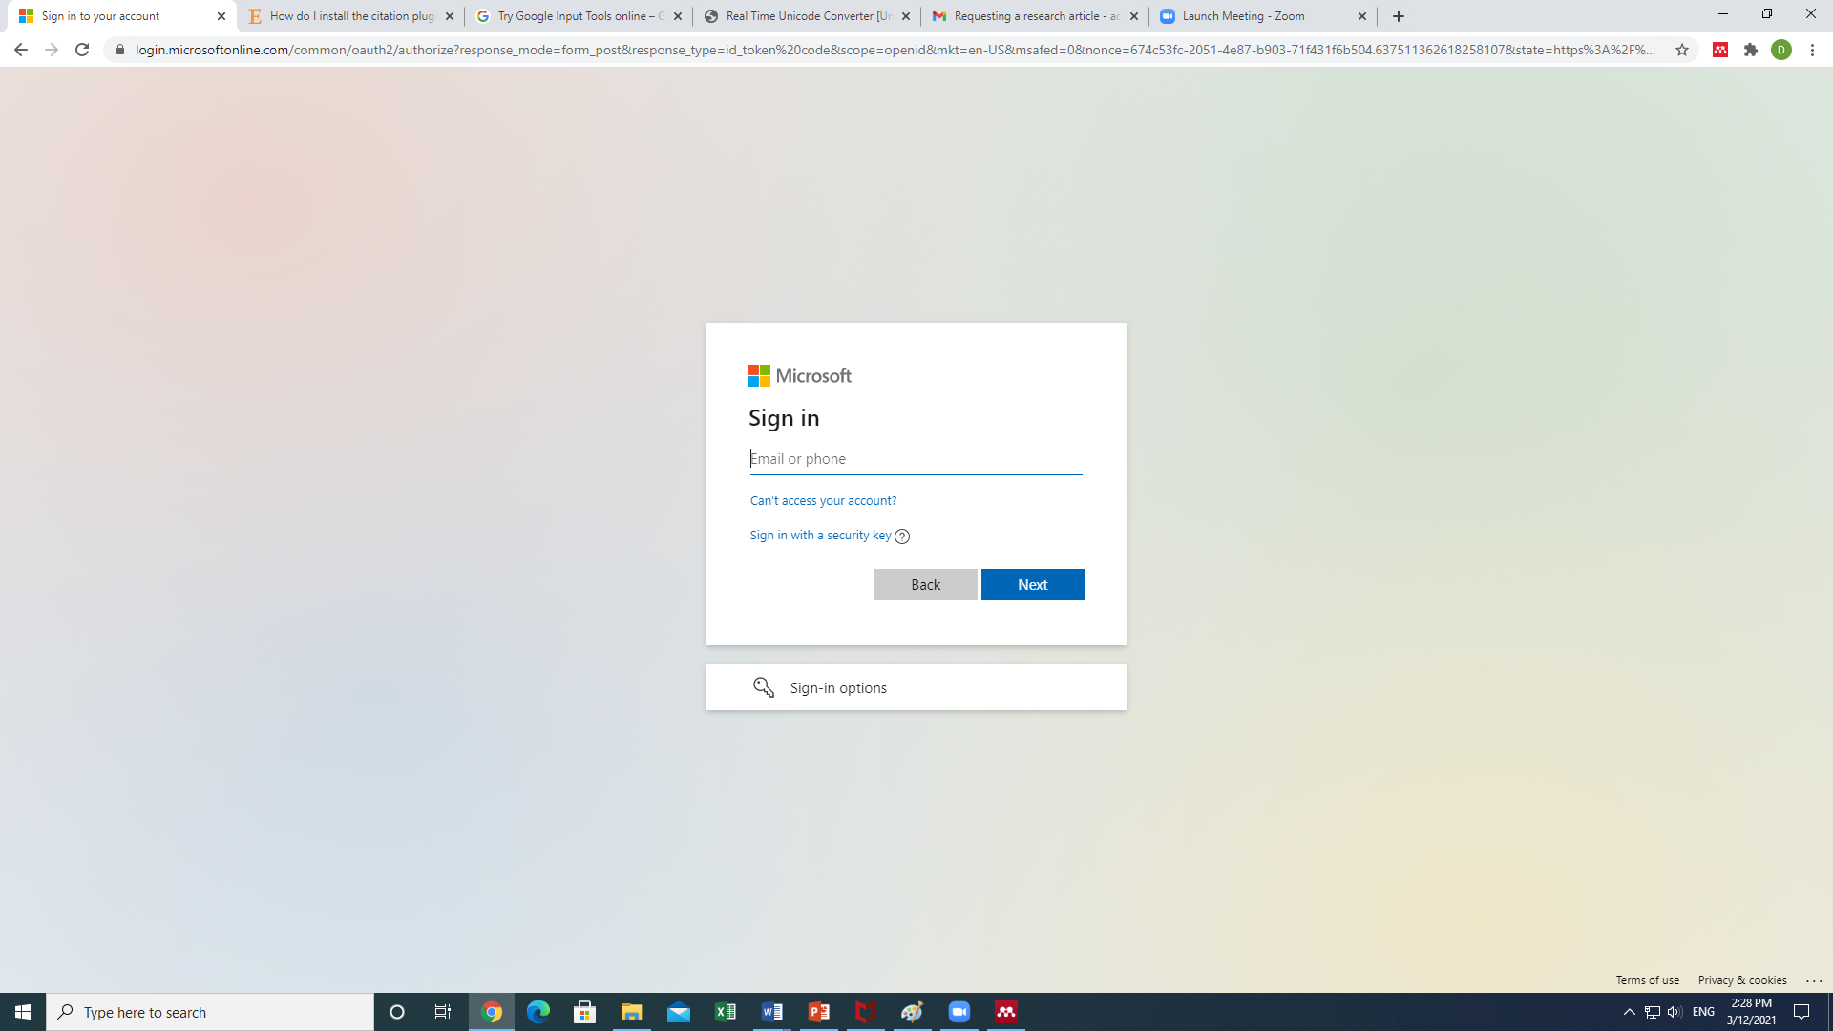

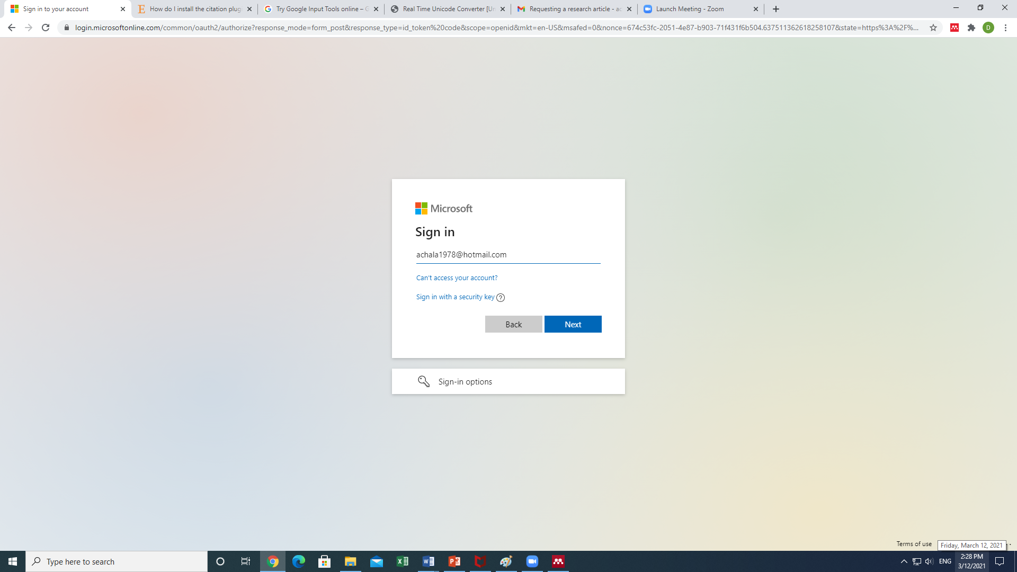

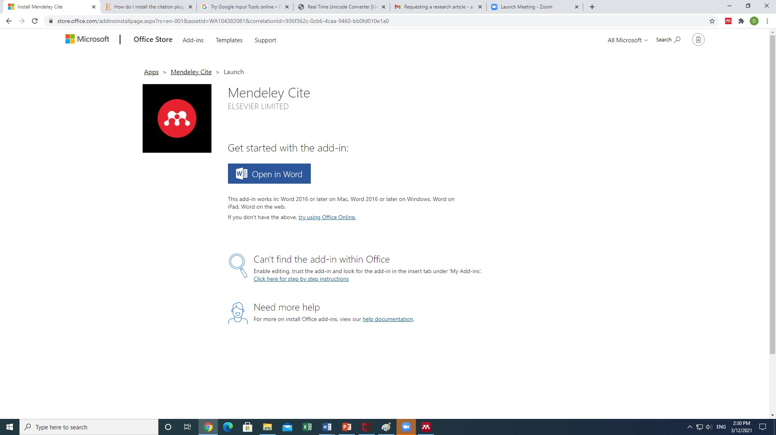

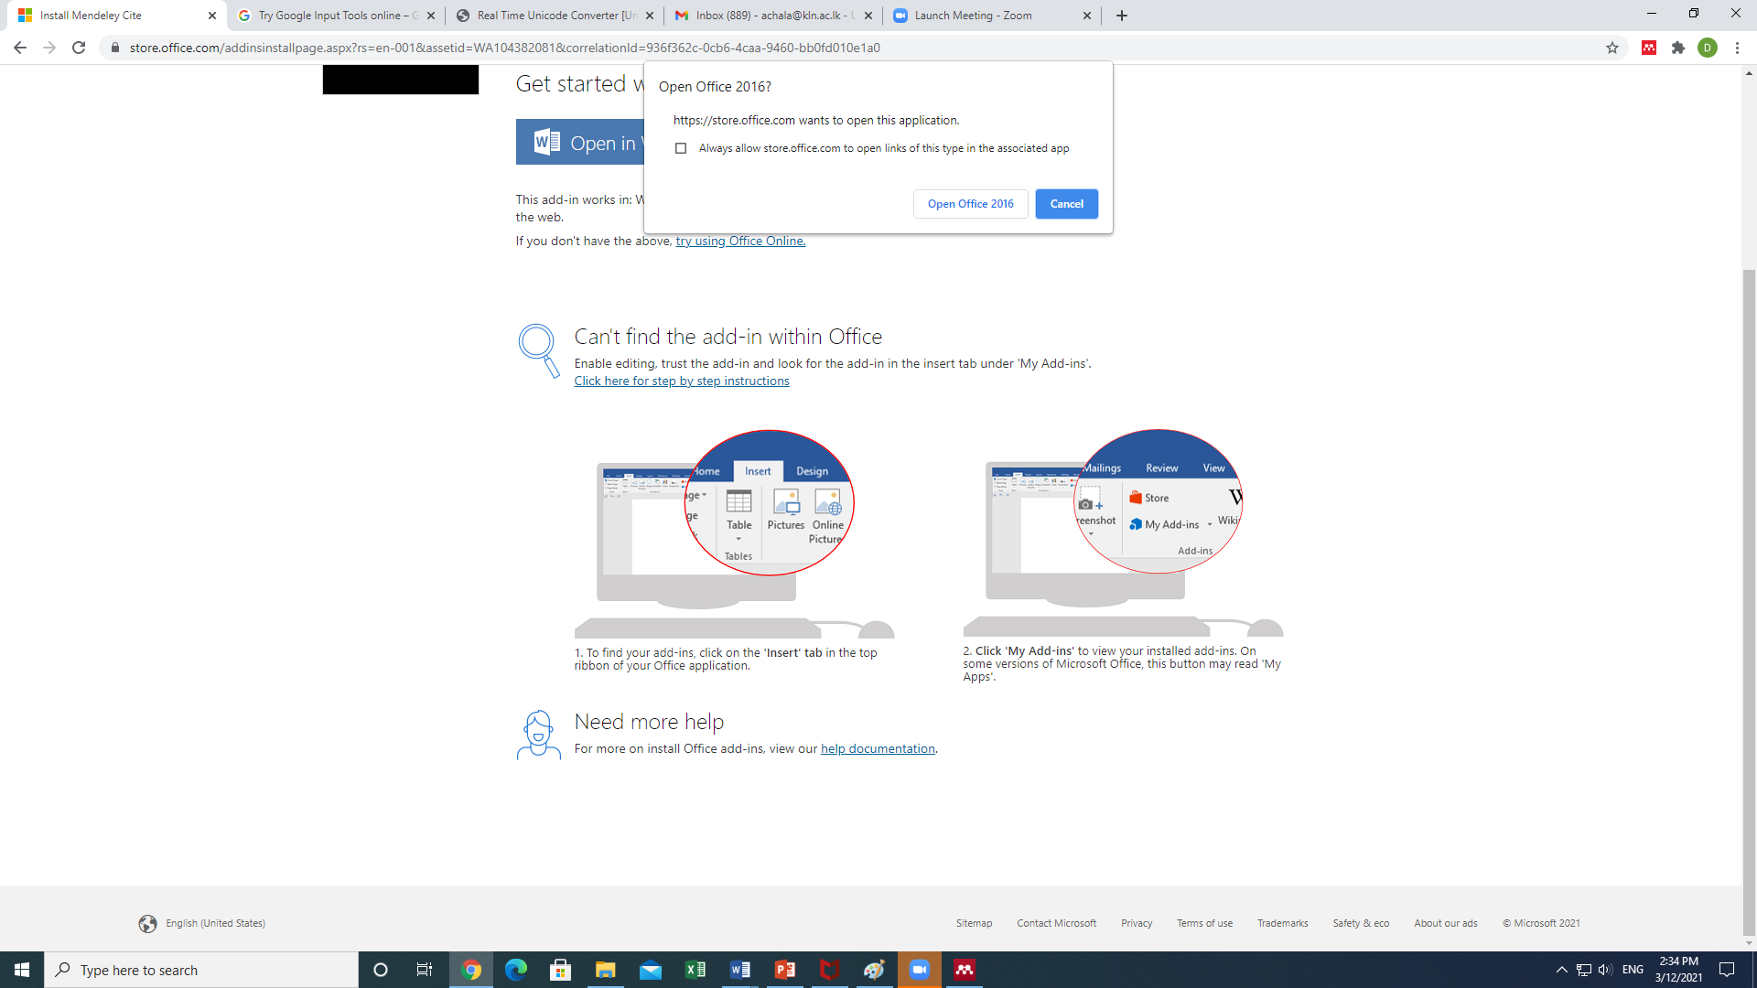

Tnf.a mß.Klfhys operating system tl Windows 2016 isg by<g we;akï Tng installation l%shdj,sh bÈßhg lrf.k hd yelsh' tfy;a Tnf.a mß.Klfhys operating system tl Windows 2016 my< tllakï Tn my; mshjr wkq.ukh l< hq;=h'

Click here
